

SCE Training Curriculums

Siemens Automation Cooperates with Education | 05/2017

Beschreibung: SIE_Logo_Layer_Petrol_RGB_A4_56mmTIA Portal Module 032-420

Diagnostics via the Web  
with SIMATIC S7-1500

**Matching SCE trainer packages for these training curriculums**

SIMATIC Controllers

* **SIMATIC ET 200SP Open Controller CPU 1515SP PC F and HMI RT SW**Order no.: 6ES7677-2FA41-4AB1
* **SIMATIC ET 200SP Distributed Controller CPU 1512SP F-1 PN Safety**

Order no.: 6ES7512-1SK00-4AB2

* **SIMATIC CPU 1516F PN/DP Safety**

Order no.: 6ES7516-3FN00-4AB2

* **SIMATIC S7 CPU 1516-3 PN/DP**Order no.: 6ES7516-3AN00-4AB3
* **SIMATIC CPU 1512C PN with Software and PM 1507**Order no.: 6ES7512-1CK00-4AB1
* **SIMATIC CPU 1512C PN with Software, PM 1507 and CP 1542-5 (PROFIBUS)**Order no.: 6ES7512-1CK00-4AB2
* **SIMATIC CPU 1512C PN with Software**Order no.: 6ES7512-1CK00-4AB6
* **SIMATIC CPU 1512C PN with Software and CP 1542-5 (PROFIBUS)**Order no.: 6ES7512-1CK00-4AB7

**SIMATIC STEP 7 Software for Training**

* **SIMATIC STEP 7 Professional V14 SP1 - Single license**Order no.: 6ES7822-1AA04-4YA5
* **SIMATIC STEP 7 Professional V14 SP1- Classroom license (up to 6 users)**Order no.: 6ES7822-1BA04-4YA5
* **SIMATIC STEP 7 Professional V14 SP1 - Upgrade license (up to 6 users)**Order no.: 6ES7822-1AA04-4YE5
* **SIMATIC STEP 7 Professional V14 SP1 - Student license (up to 20 users)**Order no.: 6ES7822-1AC04-4YA5

Please note that these trainer packages are replaced with successor packages when necessary.

An overview of the currently available SCE packages is provided at: [siemens.com/sce/tp](http://www.siemens.com/sce/tp)

**Continued training**

For regional Siemens SCE continued training, please contact your regional SCE contact [siemens.com/sce/contact](http://www.siemens.com/contact)

**Additional information regarding SCE**

[siemens.com/sce](http://www.siemens.com/sce)

**Information regarding use**

The SCE training curriculum for the integrated automation solution Totally Integrated Automation (TIA) was prepared for the program "Siemens Automation Cooperates with Education (SCE)" specifically for training purposes for public educational and R&D institutions. Siemens AG does not guarantee the contents.

This document is to be used only for initial training on Siemens products/systems. This means it can be copied in whole or part and given to those being trained for use within the scope of their training. Circulation or copying this training curriculum and sharing its content is permitted within public training and advanced training facilities for training purposes.

Exceptions require written consent from the Siemens AG contact: Roland Scheuerer roland.scheuerer@siemens.com.

Offenders will be held liable. All rights including translation are reserved, particularly if a patent is granted or a utility model or design is registered.

Use for industrial customer courses is expressly prohibited. We do not consent to commercial use of the training curriculums.

We wish to thank the TU Dresden, especially Prof. Dr.-Ing. Leon Urbas, the Michael Dziallas Engineering Corporation and all other involved persons for their support during the preparation of this training curriculum.

Table of contents

[1 Goal 5](#_Toc482107632)

[2 Prerequisite 5](#_Toc482107633)

[3 Required hardware and software 6](#_Toc482107634)

[4 Theory 7](#_Toc482107635)

[4.1 System diagnostics: Automated creation of error messages 7](#_Toc482107636)

[4.2 Diagnostics via web server 8](#_Toc482107637)

[4.3 Diagnostics with the integrated display 9](#_Toc482107638)

[5 Task 10](#_Toc482107639)

[6 Planning 10](#_Toc482107640)

[7 Structured step-by-step instructions 11](#_Toc482107641)

[7.1 Retrieve an existing project 11](#_Toc482107642)

[7.2 Configure the web server 12](#_Toc482107643)

[7.3 Configure the display 16](#_Toc482107644)

[7.4 Configure system diagnostics 17](#_Toc482107645)

[7.5 Activate the diagnostics of the power supply for the analog output module   
 and download the PLC 18](#_Toc482107646)

[7.6 Trigger error message 20](#_Toc482107647)

[7.7 Display alarms in Online & diagnostics 21](#_Toc482107648)

[7.8 Diagnostics for the S7-1500 via the web 23](#_Toc482107649)

[7.9 Diagnostics for the S7-1500 via the integrated display 32](#_Toc482107650)

[7.10 Checklist 33](#_Toc482107651)

[8 Additional information 34](#_Toc482107652)

Web server and advanced diagnostics

# Goal

In this module, the reader will become acquainted with additional tools that are helpful for troubleshooting.

In particular, we will show you how automated alarm texts can be generated in the TIA Portal for hardware faults and system errors. These can then be displayed not only in the TIA Portal but also on the display of the CPU as well as via the web server of the CPU 1516F-3 PN/DP. It is also possible to bring these into the message windows of HMI systems for viewing.

This module will present advanced diagnostic functions that, for example, you can test with the TIA project from the SCE\_EN\_032-410\_Basics\_Diagnostics with the SIMATIC S7-1500 module.

The SIMATIC S7 controllers listed in Chapter 3 can be used.

# Prerequisite

This chapter builds on the hardware configuration of the SIMATIC S7 CPU1516F-3 PN/DP. However, other hardware configurations can be used. You can use the following project for this chapter, for example:

SCE\_EN\_032-410\_Basics\_Diagnostics\_2\_R1503.zap13

# Required hardware and software

**1** Engineering station: requirements include hardware and operating system   
(for additional information, see Readme on the TIA Portal Installation DVDs)

**2** SIMATIC STEP 7 Professional software in TIA Portal – as of V13

**3** SIMATIC S7-1500/S7-1200/S7-300 controller, e.g. CPU 1516F-3 PN/DP –   
Firmware as of V1.6 with memory card and 16DI/16DO and 2AI/1AO  
Note: The digital inputs should be fed out to a control panel.

**4** Ethernet connection between engineering station and controller

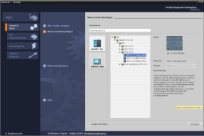

**2** SIMATIC STEP 7 Professional (TIA Portal) as of V13



**1** Engineering station

**4** Ethernet connection



Control panel

**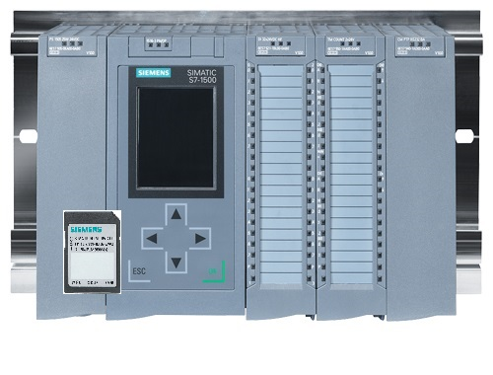**

**3** SIMATIC S7-1500 controller

# Theory

* 1. System diagnostics: Automated creation of error messages

In the TIA Portal, the diagnostics of devices and modules is collectively referred to as system diagnostics. The monitoring functions are automatically derived from the hardware configuration.

All SIMATIC products have integrated diagnostic functions which you can use to detect and remedy faults. The components automatically signal a possible disruption of operation and provide additional detailed information. Undesired downtimes can be minimized with plant-wide diagnostics.

The following states are monitored by the system in the running plant:

- Device failure

- Pull/plug error

- Module fault

- IO access error

- Channel fault

- Parameter assignment error

- Failure of the external auxiliary voltage

* 1. Diagnostics via web server

The web server enables monitoring and administering of the CPU by authorized users over a network.

This permits evaluation and diagnostics over long distances. Monitoring and evaluation is possible without the TIA Portal; all you need is a web browser.

The web server is deactivated in the delivery state of the CPU. This means that you must load a project in which the web server is activated to enable access using the web browser.

**The web server offers the following security functions:**

- Access via secure "https" transmission protocol

- User authorization by means of a user list

- Restriction of access from certain interfaces

You need a web browser to access the HTML pages of the CPU.

**The following web browsers have been tested for communication with the CPU:**

- Internet Explorer (Version 8)

- Mozilla Firefox (Version 21)

- Mobile Safari (iOS5)

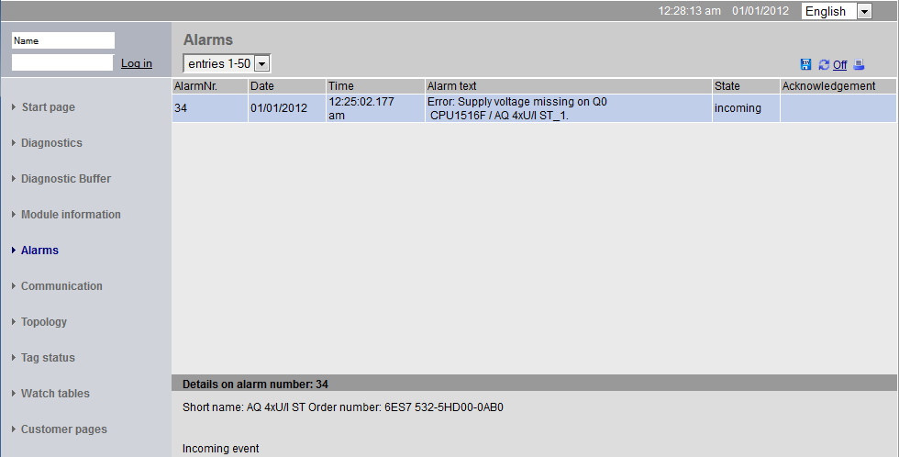

Figure 1: Web server of the CPU 1516F-3 PN/DP with alarm text from the system diagnostics

**Note:** Make sure that you protect the CPU from manipulation and unauthorized access through the use of different methods (e.g., limiting network access, using firewalls).

* 1. Diagnostics with the integrated display

The S7-1500 CPU has a front flap with a display and control keys. Control data and status data can be displayed in various menus on the display and numerous settings can be made. You use the control keys to navigate through the menus.

**The display of the CPU offers the following functions:**

- 6 different display languages can be selected.

- Diagnostic messages are displayed in plain text.

- The interface settings can be changed locally.

- Password assignment for display operation is possible through the TIA Portal.



Figure 2: Display of the CPU 1516F-3 PN/DP with alarm text from the system diagnostics

# Task

The following advanced diagnostic functions will be shown and tested in this chapter:

* Configuration of web server of the CPU 1516F-3 PN/DP
* Configuration of display of the CPU 1516F-3 PN/DP
* Create hardware fault and system error alarms with the system diagnostics
* Display alarms via the web server of the CPU 1516F-3 PN/DP
* Display alarms via the integrated display of the CPU 1516F-3 PN/DP

# Planning

The diagnostic functions will be performed using a finished project as an example. A project in the TIA Portal that was previously downloaded to the controller should be open for this. In our case, once you have started the TIA Portal, you will retrieve a previously created project that was archived and download it to the associated controller.

You can then configure the web server, the display and the system diagnostics in the TIA Portal. To test the system diagnostics, we will disconnect the monitored analog output module from its supply voltage.

# Structured step-by-step instructions

You can find instructions on how to carry out planning below. If you already have a good understanding of everything, it will be sufficient to focus on the numbered steps. Otherwise, simply follow the detailed steps in the instructions.

* 1. Retrieve an existing project
* Before we begin with diagnostics via the web server, we need a project from the SCE\_EN\_032-410 Basics\_Diagnostics module.   
  (e.g., SCE\_EN\_032-410\_Basics\_Diagnostics\_2\_R1503.zap13)   
  To retrieve an existing project that has been archived, you must select the relevant archive with →Project →Retrieve in the project view.   
  Confirm your selection with "Open".   
  (→ Project → Retrieve → Select a .zap archive → Open)

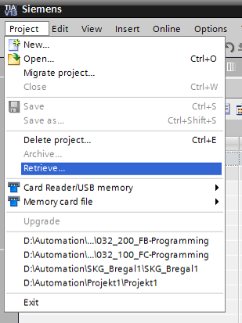

* The next step is to select the target directory where the retrieved project will be stored. Confirm your selection with "OK".   
  (→ Target directory → OK)
  1. Configure the web server
* To configure the web server, open the device configuration of the CPU 1516F-3 PN/DP. (→ CPU\_1516F [CPU 1516F-3 PNDP] → Device configuration)

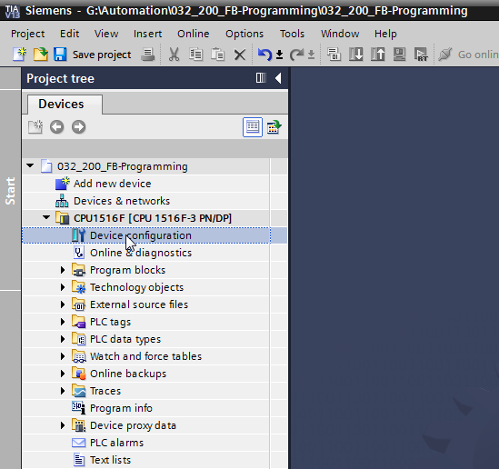

* Select the CPU and choose the 'Web server' menu item in the properties.   
  (→ CPU\_1516F → Properties → Web server)

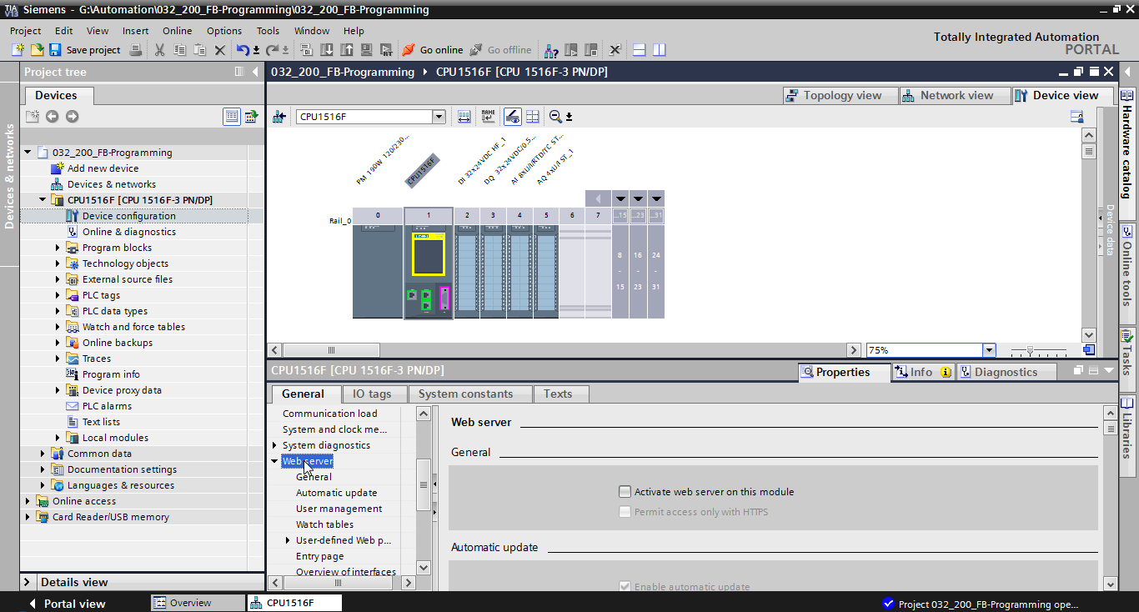

* Activate the web server on this module and confirm the security note.   
  (→  Activate web server on this module → OK)

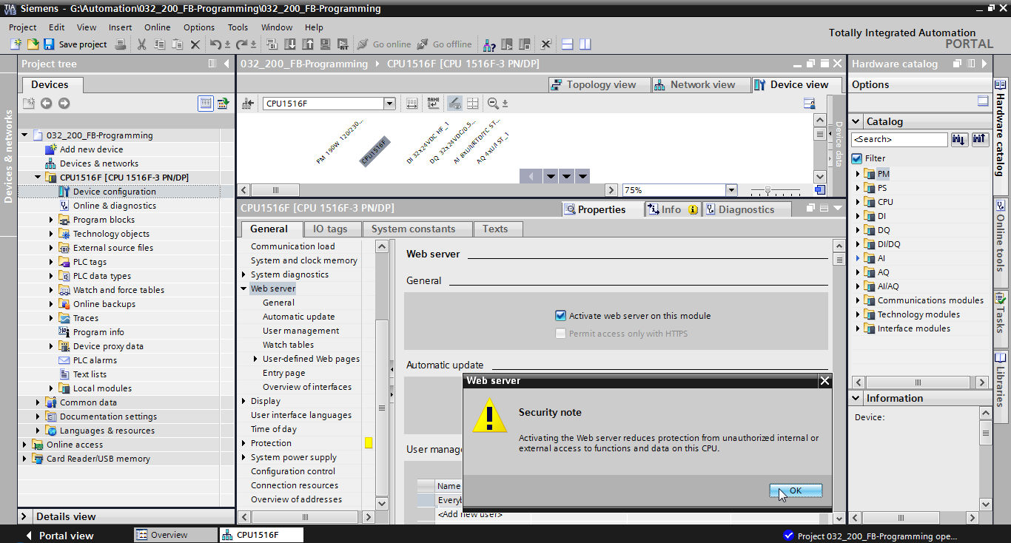

* Leave the check mark  for 'Enable automatic update', and select the security settings of the 'Everybody' user. Enable this user to carry out all possible actions and accept your settings.   
  (→  → )

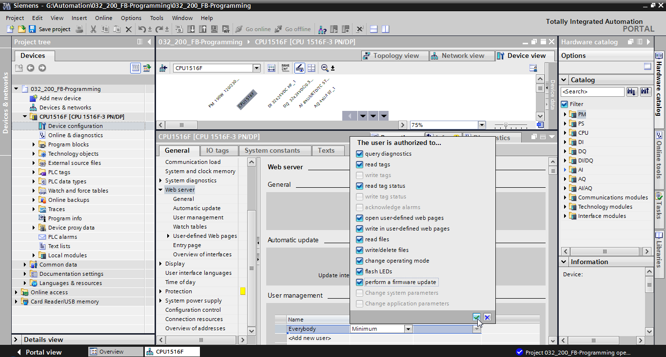

**Notes:** You can also create multiple users here with different authorizations. These users then require a password.

* As a result of these authorizations, the 'Everybody' user is now automatically assigned the access level 'Administrative'.

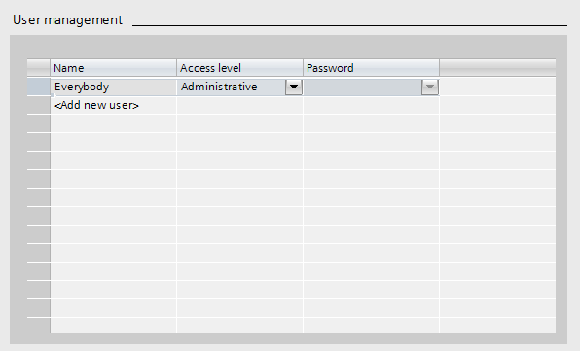

* In the 'Watch tables' menu item, the 'Watch table\_Cylinder' can now be entered in the web server.   
  (→Watch table\_Cylinder → )

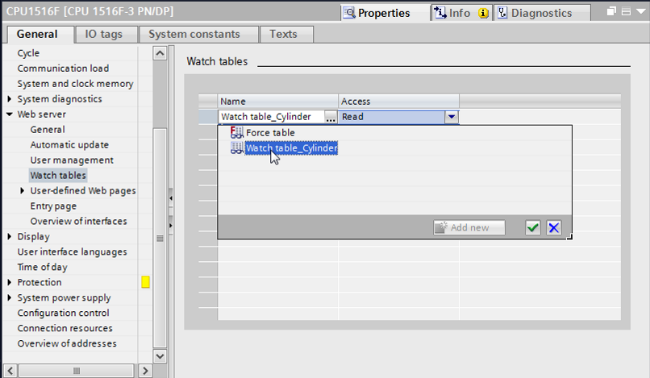

* Accessing is read-only. (→ Read)

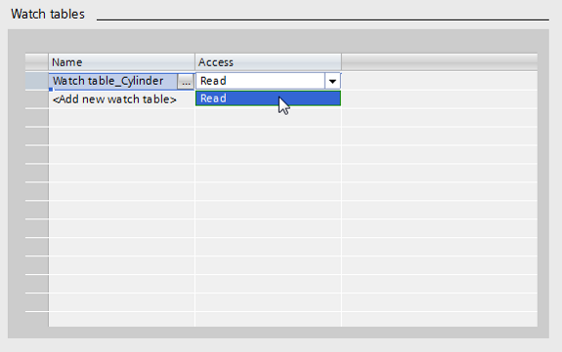

* User-defined web pages will not be created here. For reasons of plant safety / security, we will enable only PROFINET interface\_1 for access to the web server.   
  (→ Enabled web server access →  PROFINET interface\_1)

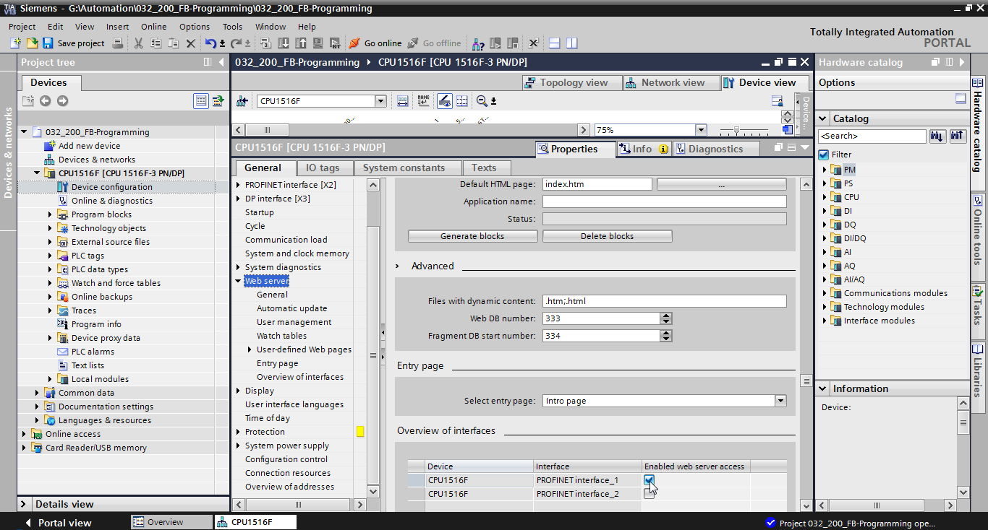

* 1. Configure the display
* The settings for the display of diagnostics data can also be changed on the integrated display of the CPU 1516F-3 PN/DP. First, the general settings are selected as shown here.   
  (→ Display → General)

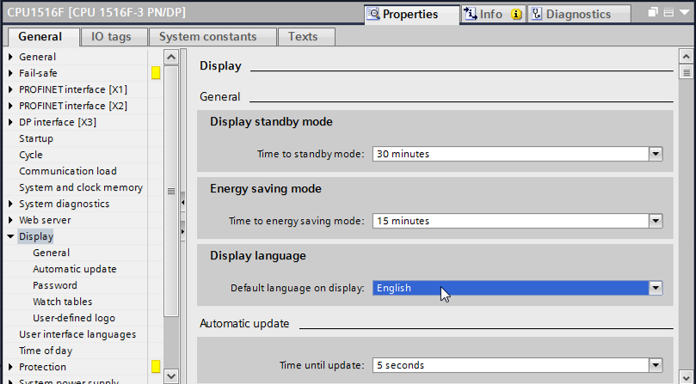

* In the 'Watch tables' menu item, the 'Watch table\_Cylinder' can now be entered in the display.   
  (→Watch table\_Cylinder → )

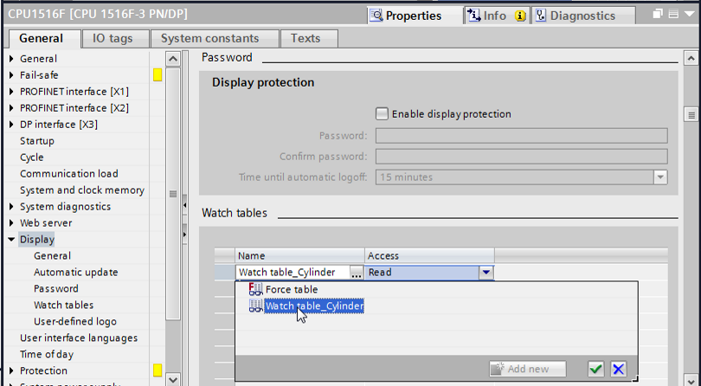

* If desired, a user-defined logo can also be shown on the display   
  (→ User-defined logo page)

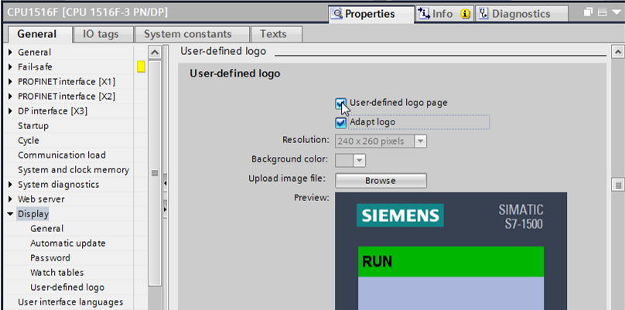

* 1. Configure system diagnostics
* An important function for effective troubleshooting is the integrated system diagnostics. This is always activated for the SIMATIC S7-1500. The alarm categories can be selected in the alarm settings and, if desired, an 'Acknowledgment' can be specified.

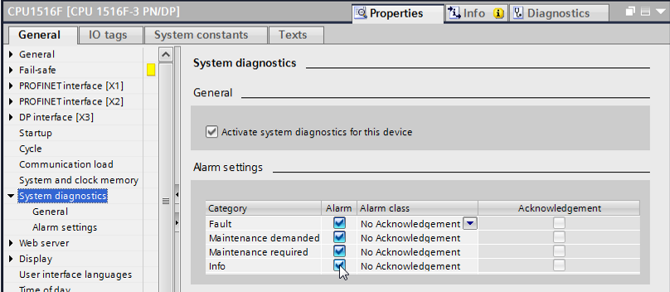

**Notes:** The indicated alarm class is important so that it can be selected in the alarm windows of the operator panel (e.g., TP1500, TP700, etc.).

* 1. Activate the diagnostics of the power supply for the analog output module and download the PLC
* Once the web server, display and system diagnostics have been configured in the controller, we also activate the diagnostics for the supply voltage for the analog output module. The controller can then be selected and downloaded together with the created program.   
  (→ Device configuration → AQ 4xU/I ST\_1 → Output 0 – 3 → Outputs → Channel 0 → Diagnostics →  No supply voltage L+→ CPU\_1516F [CPU 1516F-3 PN/DP]→ )

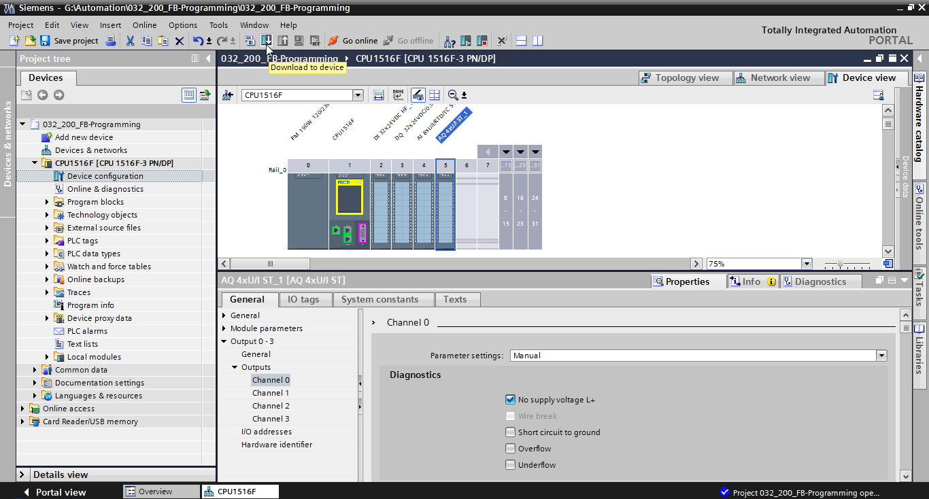

* Select the correct interface and click 'Start search'.   
  (→ PN/IE → Selection of the network adapter of the PG/PC → Direct at slot ‘1 X1‘→ Start search)

Once "Scan and information retrieval completed" appears, click 'Load'.   
(→ Load)

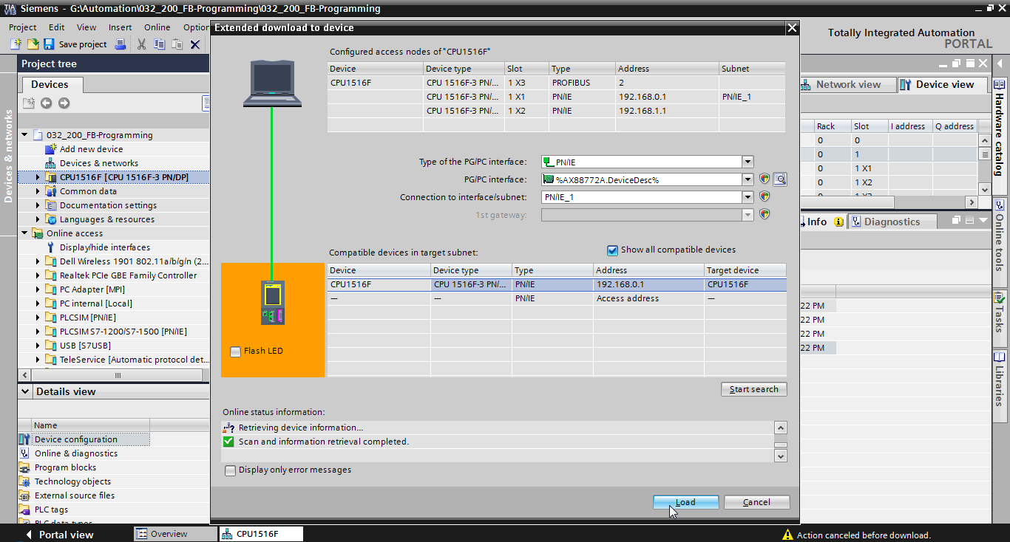

* Before downloading can be started, other actions may have to be selected. Click 'Load' again.   
  (→ override all →Load)

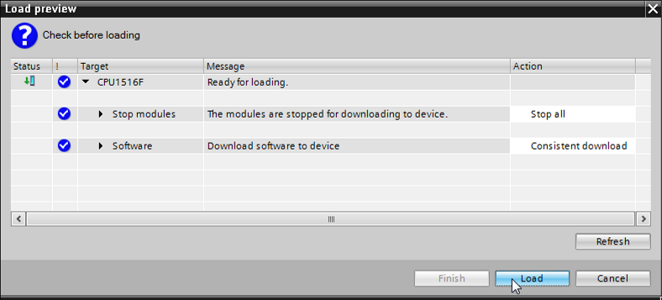

* After loading, first select the "Start all" check box and click 'Finish'.   
  (→ Start all → Finish)

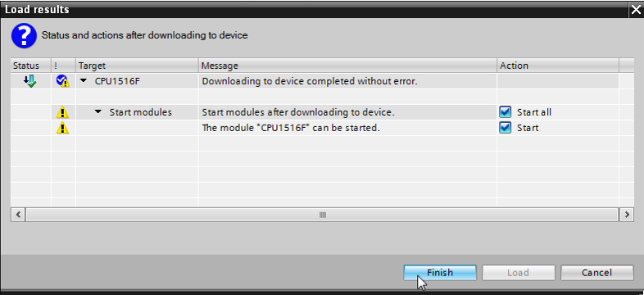

* 1. Trigger error message
* The power supply of the analog output module is via terminals 41-44 of the supply element. Remove this supply element, as shown here, from the front connector to trigger an error message. Result: the red ERROR LED on the CPU is lit and an error message is triggered. The following pages describe where and how you can view this error message.

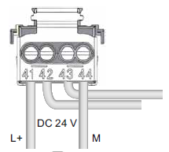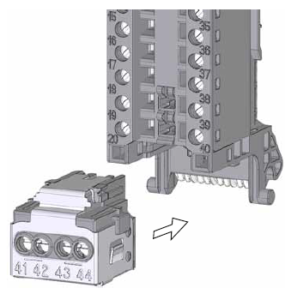

* 1. Display alarms in Online & diagnostics
* To get started with the diagnostic functions, we will select our controller 'CPU\_1516F' and click 'Online & diagnostics'. Under 'Online access' select  'Receive alarms' for the 'Alarms' item.   
  (® CPU\_1516F ® Online & diagnostics ® Online access ® Alarms ®  Receive alarms)

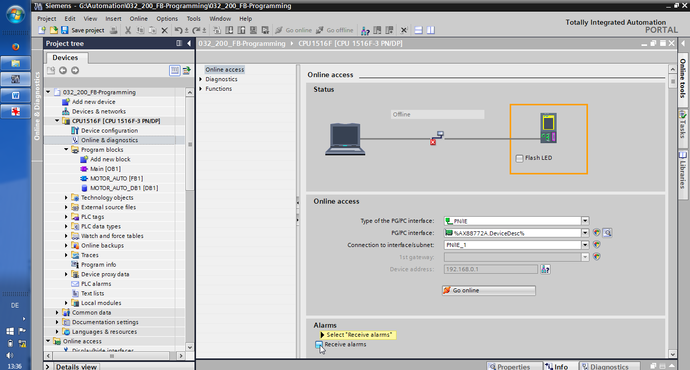

* Select the correct interface and click 'Go online'.   
  (→ Go online)

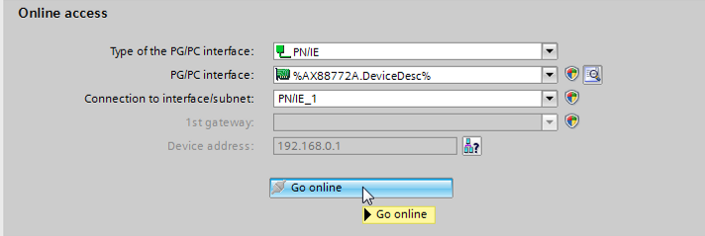

* The error message can now be checked in the 'Alarm display' under 'Diagnostics'.   
  (→ Diagnostics → Alarm display)

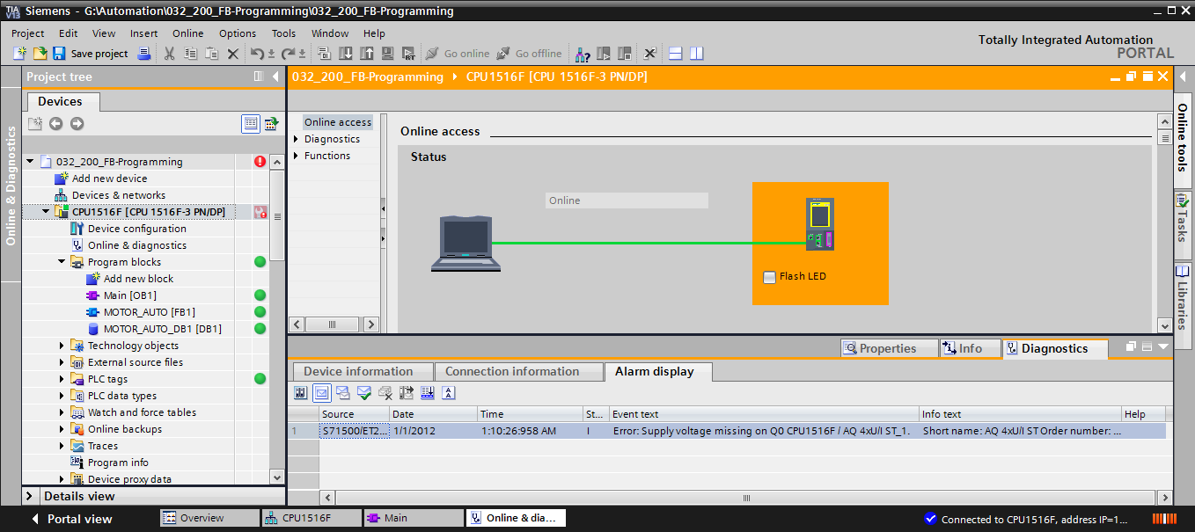

* 1. Diagnostics for the S7-1500 via the web
* To be able to access the Web server of the CPU 315F-2 PN/DP we open any Web browser on a PC that is connected to the CPU via TCP/IP.

056

* There we enter the IP address of the CPU 1516F-3 PN/DP. (® 192.168.0.1)

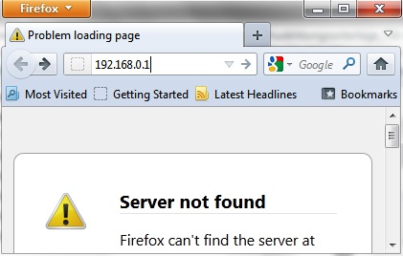

* On the displayed web page, we first select the language and then click '**ENTER**'.   
  (® English ® ENTER)

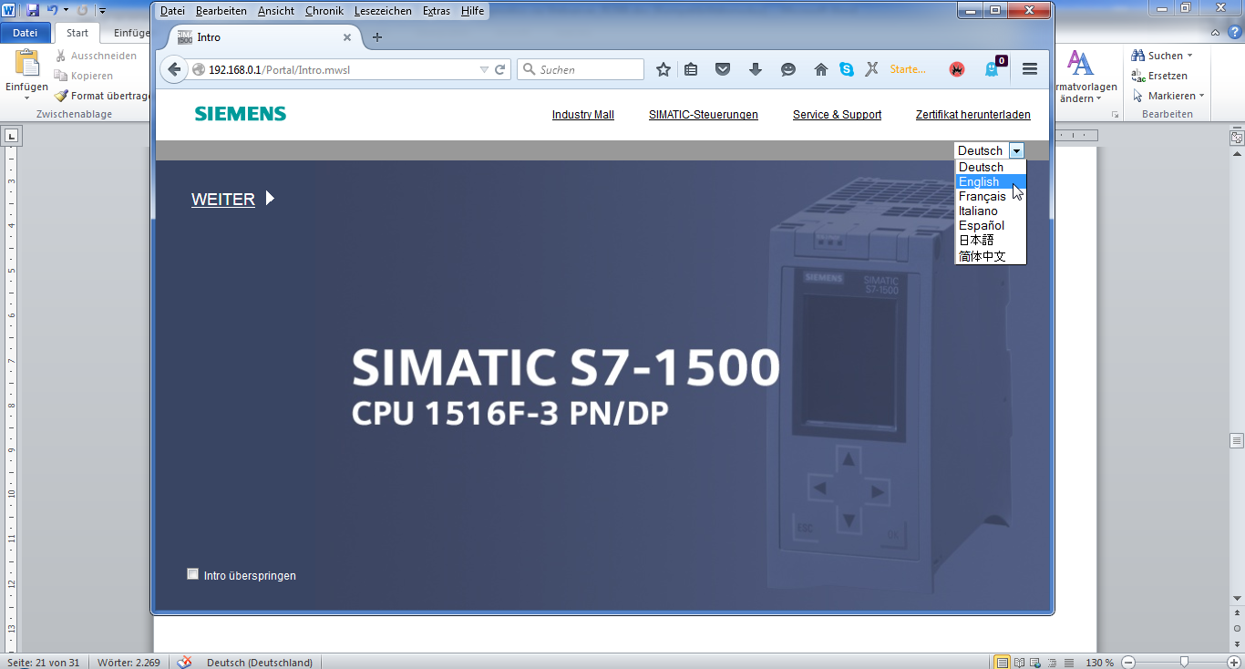

* On the '**Home Page**' we see general information about the PLC and its status.   
  (® Home Page)

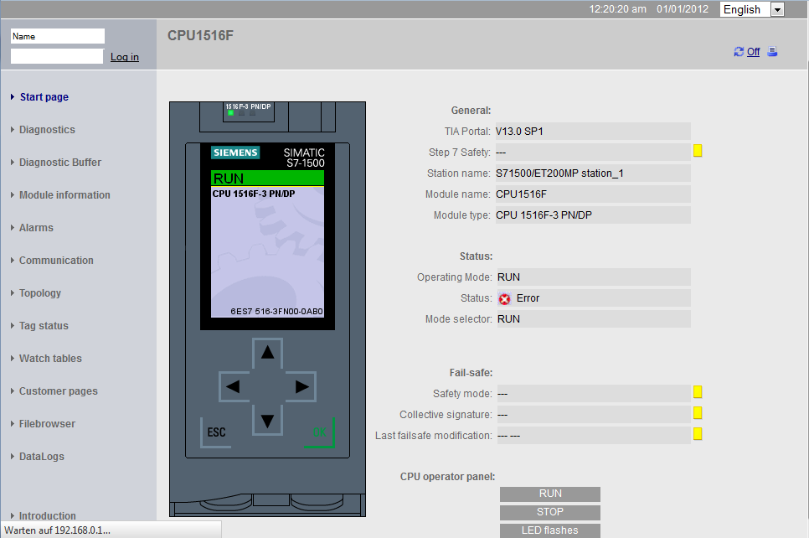

* Hardware, Firmware Version and Serial number are displayed besides other information under 'Diagnostics'.   
  (® Diagnostics)

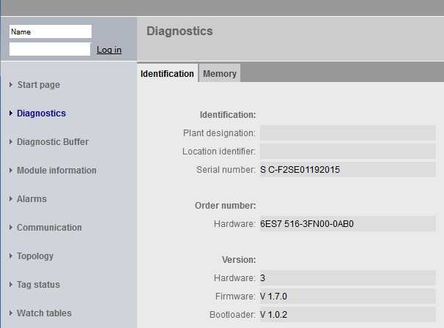

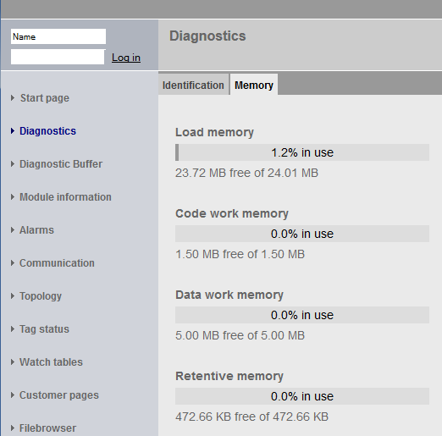

* Under 'Diagnostics Buffer' we see descriptive information for all events in the CPU. Event information is recorded in a circular buffer. The most recent alarm is displayed in the top line.   
  (→ Diagnostics Buffer)

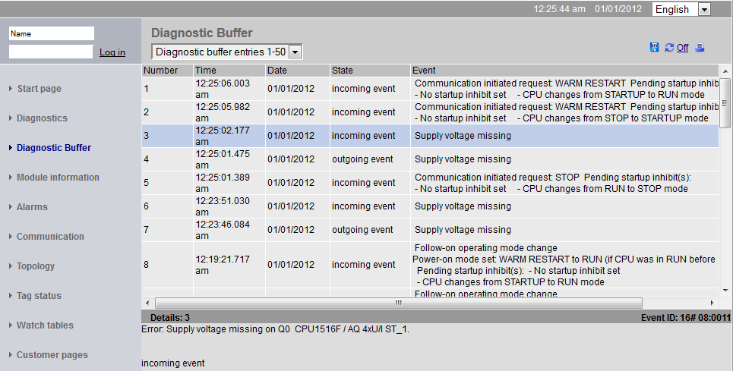

* The status of the individual modules of our SIMATIC S7-1500 is displayed with additional details in the 'Module Information' view.   
  (® Module Information)

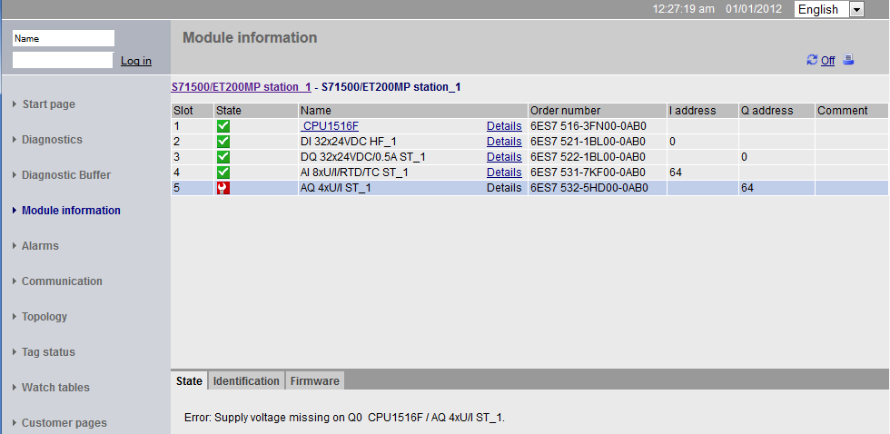

* The alarm texts generated in the CPU 1516F-3 PN/DP are available in 'Alarms'.   
  (® Alarms)



**Note:** Here we see the failure of the supply voltage for the digital input module with activated diagnostic error interrupt.

* Details about communication settings and communication errors are displayed under 'Communication'.   
  (® Communication)

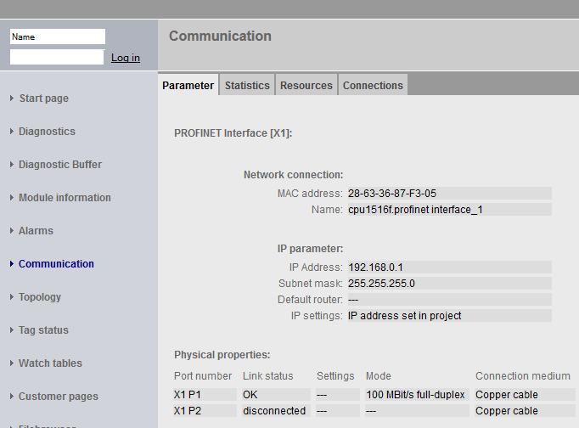

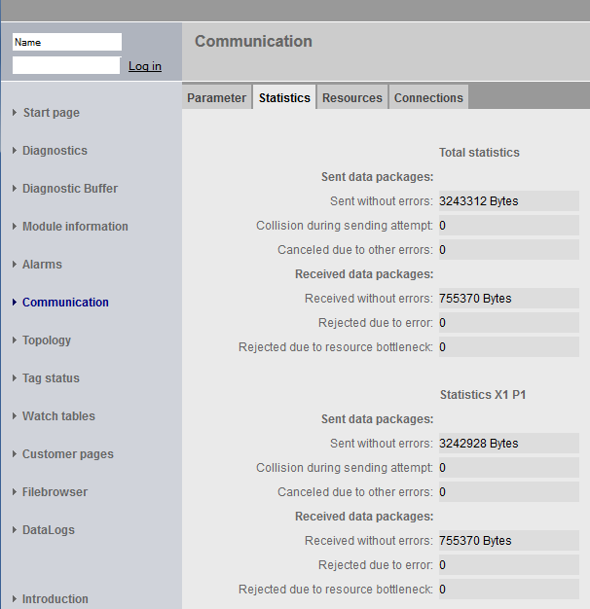

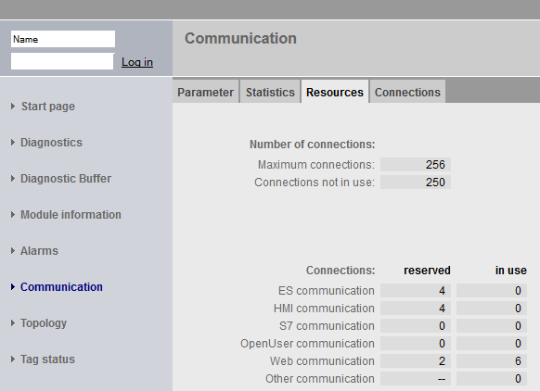

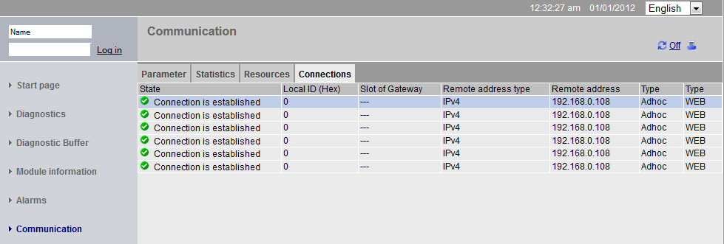

* Devices that are connected to the individual ports of the CPU 1516F-3 PN/DP and the addresses of these devices can be displayed under 'Topology'. There are various views for this. In the case of larger network structures, the entire network structure of a plant can be displayed and faulty connections shown in the status, provided this function is supported by the individual components.   
  (® Topology)

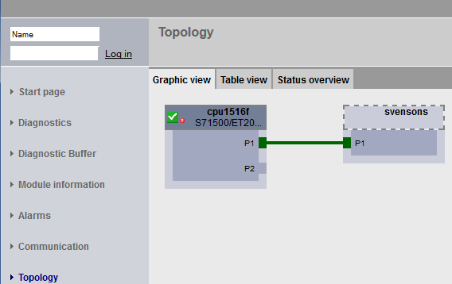

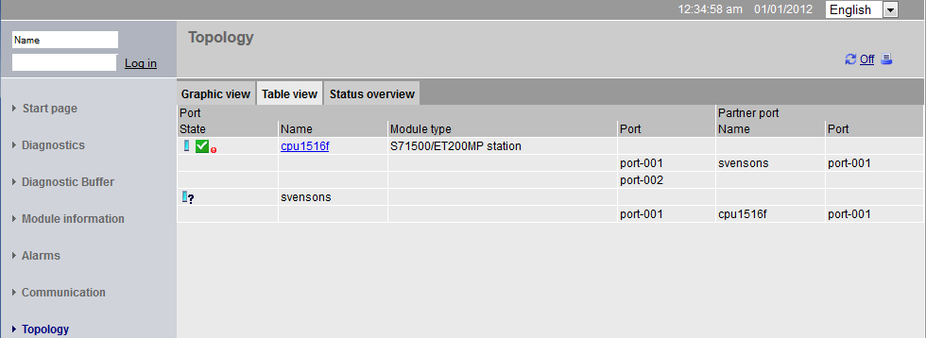

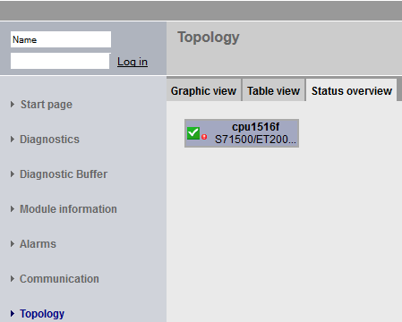

* Values of the individual tags can be displayed under 'Tag status'.  
  (® Tag status)

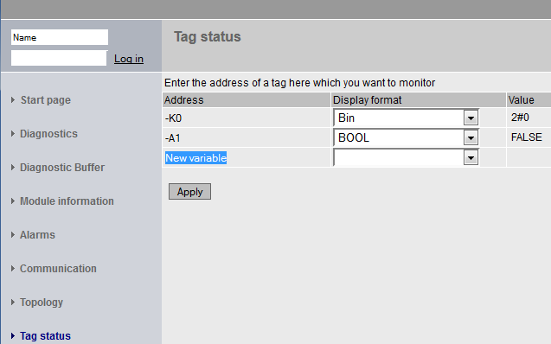

* 'Tag tables' that are linked with the web server, such as the 'Watch table\_Cylinder', can also be displayed.   
  (® Tag tables ® Watch table\_Cylinder)

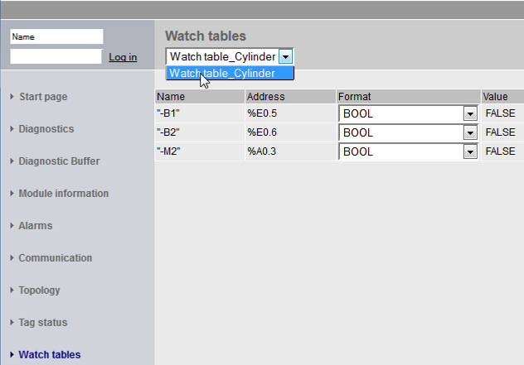

* Individually created pages for the visualization and also for operator control of processes would be seen under 'Customer pages'.  
  (® Customer pages)

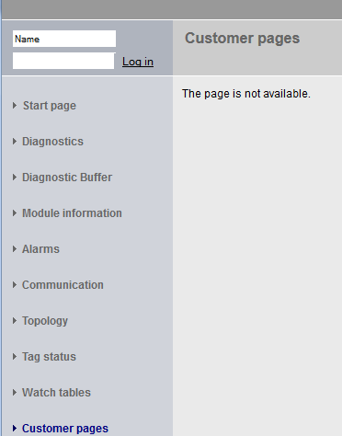

* Data can be stored directly on the memory card in the CPU or loaded from there using the 'Filebrowser'.   
  (→ Filebrowser)

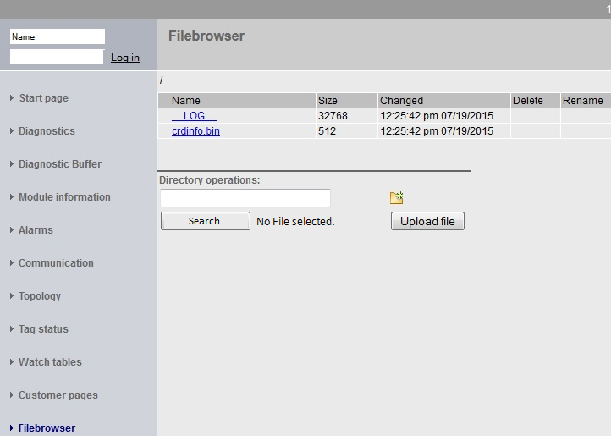

* This means, for example, that you can read and edit the log files written by the CPU without having to use the TIA Portal. (→ DataLogs)

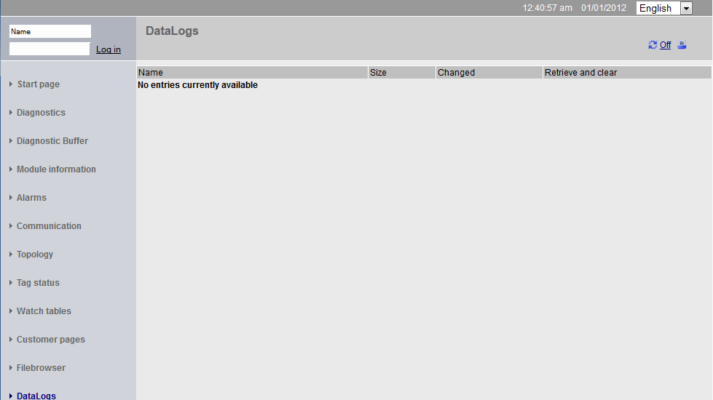

* 1. Diagnostics for the S7-1500 via the integrated display
* The user also has the ability to call up a variety of diagnostic information via the display. For example, the alarm texts generated by the system diagnostics can be displayed in the 'Diagnostics' menu under 'Alarms'.   
  (® Diagnostics ® Alarms)

 

* 1. Checklist

|  |  |  |
| --- | --- | --- |
| **No.** | **Description** | **Completed** |
| 1 | Project 032-410\_Basics\_Diagnostics\_2… successfully retrieved. |  |
| 2 | Web server for the CPU 1516F from project 032-410\_Basics Diagnostics\_2… successfully configured. |  |
| 3 | Display for the CPU 1516F from project 032-410\_Basics Diagnostics\_2… successfully configured. |  |
| 4 | System diagnostics for the CPU 1516F from project 032-410\_Basics Diagnostics\_2… successfully configured. |  |
| 5 | Diagnostics of the supply voltage for the analog output module activated. |  |
| 6 | CPU 1516F from project 032-410\_Basics Diagnostics\_2… successfully downloaded. |  |
| 7 | Power supply disconnected from analog output module. |  |
| 8 | Display of alarm text from the system diagnostics in the alarm display of the TIA Portal. |  |
| 9 | Display of the alarm text from the system diagnostics via the web server of the CPU 1516F. |  |
| 10 | Display of the alarm text from the system diagnostics on the display of the CPU 1516F. |  |

# Additional information

You can find additional information as an orientation aid for initial and advanced training, for example: Getting Started, videos, tutorials, apps, manuals, programming guidelines and trial software/firmware, at the following link:   
  
www.siemens.com/sce/s7-1500